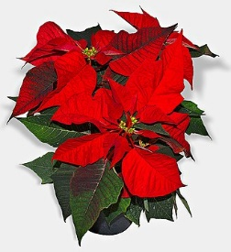**Glacier’s Edge Council Poinsettia Sale**

6 ½” Red Poinsettia in basic foil pot cover with a bow

Pack/Troop/Crew #: __________

Scout Name: ___________

Phone Number: _________

Price: $21.00 Each Make Checks Payable to: __________________

|  |  |  |  |  |  |
| --- | --- | --- | --- | --- | --- |
| **Name** | **Address** | **Phone** | **Quantity** | **Amount**  **Due** | **Paid** |
|  |  |  |  |  |  |
|  |  |  |  |  |  |
|  |  |  |  |  |  |
|  |  |  |  |  |  |
|  |  |  |  |  |  |
|  |  |  |  |  |  |
|  |  |  |  |  |  |
|  |  |  |  |  |  |
|  |  |  |  |  |  |
|  |  |  |  |  |  |
|  |  |  |  |  |  |