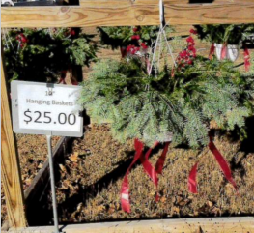
Glacier’s Edge Council Hanging Wreath Basket Sale
Pack/Troop/Crew #: ___________ 10” Basket that flows
Scout Name: _________________ with greenery
Phone Number: ______________ Price $25.00 each
Make Checks Payable to: ________________
Name | Address | Phone | Quantity | Amount Due | Paid

